Chapter 4: Multithreaded Architecture
4.1 Latency Hiding Techniques
- What is the primary purpose of latency hiding techniques in multithreaded architecture, and how do these techniques improve overall system performance? (CA / Old)
The primary purpose of latency hiding is to prevent the processor from remaining idle during high-latency operations such as cache misses, memory accesses, I/O operations, and remote memory references.
It achieves this by overlapping the waiting time of one thread with the useful execution of another ready thread.

How It Improves System Performance
- Reduces Processor Idle Time:
When one thread stalls, the processor switches to another ready thread instead of waiting.
- Fast Context Switching:
Hardware maintains multiple thread contexts such as registers and the Program Counter (PC), allowing rapid switching between threads.
- Increases Throughput:
Useful instructions from other threads fill the pipeline slots that would otherwise be wasted, increasing overall instruction throughput.
- Hides Memory Latency:
During a cache miss or slow main-memory access, another thread can execute while the required data is being fetched.
- Improves Hardware Utilization:
Techniques such as SMT allow instructions from multiple threads to use available execution units, keeping the processor resources busy.
- Supports Large-Scale Parallel Systems:
In distributed systems, computation from one thread can continue while another waits for remote memory or network data.

Example
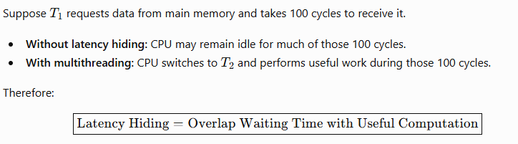
Conclusion: Latency hiding does not necessarily reduce the actual latency of an operation; instead, it reduces its impact on system performance by keeping the processor busy, thereby improving throughput, resource utilization, and overall system efficiency.

- What is latency hiding? Explain how multithreading helps in hiding latency with suitable examples. (2025 Fall New)

Latency Hiding
Latency hiding is a technique used to reduce the performance impact of delays by overlapping a waiting operation with useful computation. Instead of keeping the processor idle during memory, I/O, network, or execution latency, the processor performs other useful work.

How Multithreading Hides Latency
Multithreading allows multiple threads to share processor resources. When one thread becomes stalled because it is waiting for data, the processor switches to another ready thread.
The process is:
- Thread (T1) requests data from memory.
- (T1) becomes stalled due to memory latency.
- The processor switches to (T2).
- (T2) performs useful computation while (T1) waits.
- When the required data arrives, (T1) resumes execution.
Thus, the waiting time of (T1) is overlapped with useful computation of (T2).

Types of Multithreading
- Fine-grained multithreading: Switches between threads frequently, often every clock cycle.
- Coarse-grained multithreading: Switches when a thread encounters a major stall such as a cache miss.
- Simultaneous Multithreading (SMT): Instructions from multiple threads can execute in the same clock cycle.
- Massive multithreading: GPUs maintain thousands of threads and switch to another ready thread when one is waiting for memory.

Suitable Examples
1. Cache Miss:
If (T1) experiences a cache miss, the processor executes (T2) while data is fetched from main memory. Therefore, memory latency is hidden.
2. Network Access:
If (T1) waits for data from a remote computer, (T2) can perform other computations during the network delay.
3. GPU Processing:
When one GPU warp stalls because of a memory access, another ready warp is scheduled. This keeps the GPU execution units busy.

Conclusion
Latency hiding does not necessarily reduce the actual latency; it reduces its effect on overall performance. Multithreading achieves this by overlapping latency with useful computation, thereby improving processor utilization and throughput.

4.2–4.3 Multithreading Principles & Architectures
- What is a multithreading architecture? Explain the principles used in multithreading architecture to increase the throughput of a computer. (2024 Fall)
A multithreading architecture is a processor architecture that allows a single CPU core to maintain and execute multiple threads concurrently. Each thread has its own hardware context, such as Program Counter (PC), registers, and status information, while the processor's execution units, caches, and memory system are shared.
The main goal is to exploit Thread-Level Parallelism (TLP) and increase computer throughput.

Principles Used to Increase Throughput
- Latency Hiding
When one thread stalls due to a cache miss, memory access, or I/O operation, another ready thread is executed. Thus, waiting time is overlapped with useful computation.
- Fast Hardware Context Switching
The processor maintains multiple thread contexts in hardware. Therefore, switching between threads is very fast because registers and the PC do not need to be saved and restored to memory.
- Thread-Level Parallelism (TLP)
Instructions from independent threads provide more opportunities for parallel execution. This helps overcome limitations caused by data and control dependencies within a single thread.
- Efficient Resource Utilization
Multiple threads share resources such as ALUs, floating-point units, caches, and memory buses. When one thread cannot use a resource, another thread can utilize it, reducing hardware idle time.
- Thread Scheduling and Interleaving
Multithreading uses different approaches:
  - Fine-Grained Multithreading: switches between threads frequently, often every clock cycle.
  - Coarse-Grained Multithreading: switches when the current thread encounters a major stall.
  - Simultaneous Multithreading (SMT): issues instructions from multiple threads in the same clock cycle.
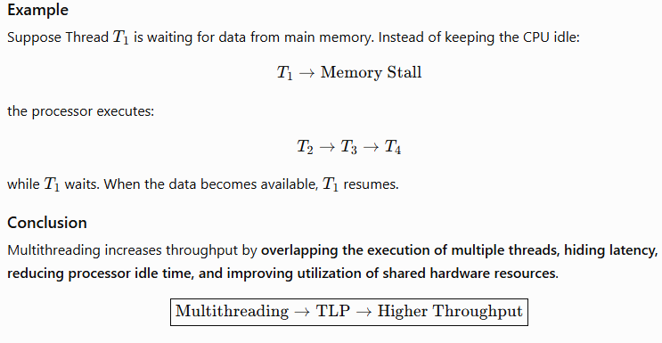

- What is multithreading? How can it help to enhance the performance of a computer? Explain the issues of multithreading. (2025 Fall Mock)

Issues of Multithreading
- Synchronization:
Shared data requires locks, mutexes, semaphores, and barriers, which add complexity and overhead.
- Race Conditions:
Multiple threads accessing shared data simultaneously can produce incorrect or unpredictable results.
- Deadlock:
Two or more threads may wait indefinitely for resources held by each other.
- Starvation:
A thread may continuously be denied CPU time or required resources.
- Resource Contention:
Threads compete for shared CPU resources, cache, memory bandwidth, and TLB, which can reduce performance.
- False Sharing:
Different variables modified by different threads may occupy the same cache line, causing unnecessary cache-coherence traffic.
- Debugging Complexity:
Non-deterministic execution makes multithreaded programs difficult to test and debug.

Conclusion
Multithreading improves computer performance by exploiting TLP, hiding latency, increasing throughput, and improving resource utilization. However, synchronization, race conditions, deadlocks, resource contention, false sharing, and debugging complexity are major challenges.

4.4–4.8 Cluster, Grid, and Neural Computing
- Compare the cluster computing with grid computing showing similarities as well as differences. (2024 Fall)

1. Cluster Computing
Cluster computing is a system in which a group of interconnected computers, called nodes, work together as a single computing system. The nodes are usually located in the same place and connected through a high-speed network.

2. Grid Computing
Grid computing is a distributed computing system that combines computing resources from different locations and organizations to solve large and complex problems. The resources may be geographically distributed and heterogeneous.
Cluster:
A university has 20 identical computers in one laboratory connected by a high-speed network. They work together to perform a weather simulation.
Grid:
Universities in Nepal, India, Japan, and the USA contribute their available computers to a common research project. The computers work together over wide-area networks.
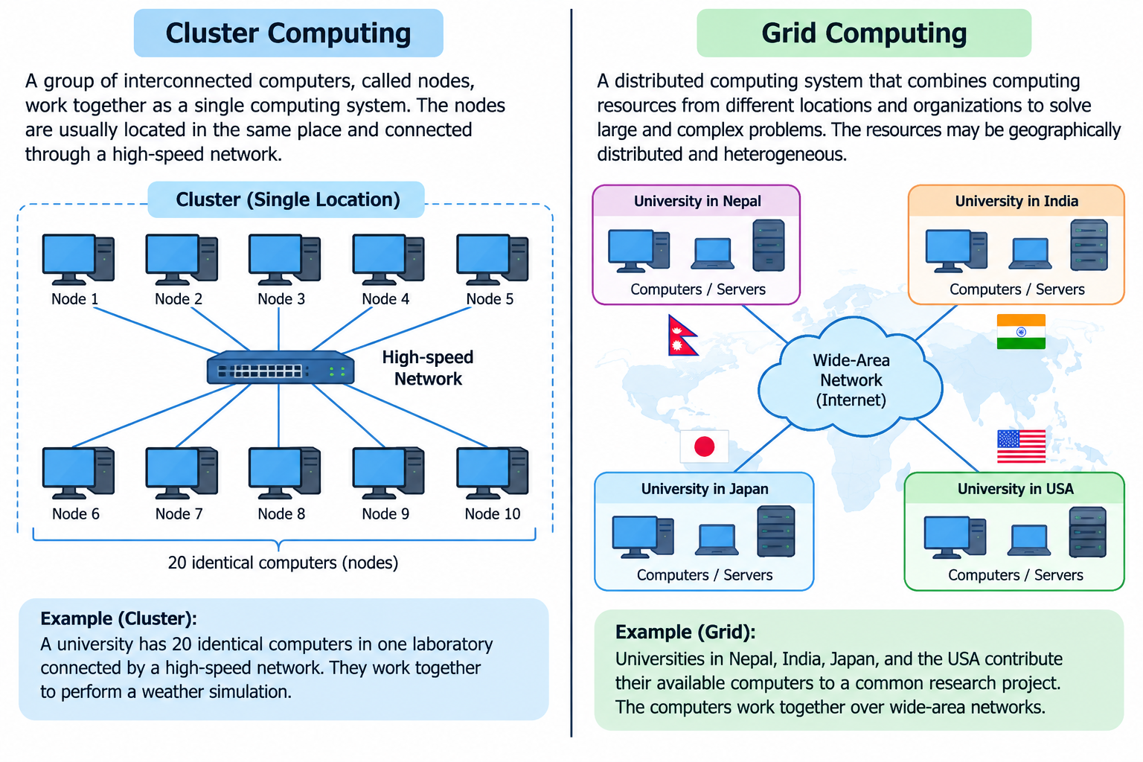

Similarities between Cluster and Grid Computing
- High Performance: Both are used to solve large, complex, and computationally intensive problems.
- Multiple Computers: Both use multiple independent computers connected through a network.
- Parallel Processing: Tasks can be divided into smaller parts and processed concurrently.
- Distributed Computing: Both are based on the concept of distributed computing and resource sharing.
- Scalability: Both systems can improve performance by adding additional computing nodes.
- Fault Tolerance: Failure of one node can be handled by redistributing or recovering tasks, depending on the system design.
- Communication: Both require communication mechanisms such as message passing to coordinate tasks between nodes.

Differences between Cluster and Grid Computing
Feature | Cluster Computing | Grid Computing
Coupling | Tightly coupled | Loosely coupled
Location | Usually in one location | Geographically distributed
Hardware | Usually homogeneous | Usually heterogeneous
Operating System | Generally similar OS | May use different operating systems
Administration | Usually under one organization | May involve multiple organizations
Control | Centralized management | Decentralized management
Network | High-speed LAN/interconnect | Internet/WAN or other networks
Communication Latency | Low | Relatively high
Resource Allocation | Dedicated and relatively static | Shared and dynamic
System View | Often works like a single system | Nodes remain independent
Main Purpose | Tightly coupled parallel applications | Large distributed workloads and resource sharing
Example | HPC cluster in a research center | SETI@home or a multi-university research grid

Simple Example

Conclusion
Cluster computing uses a group of closely connected computers under relatively centralized control and is suitable for applications requiring fast communication and synchronization. Grid computing combines geographically distributed and heterogeneous resources and is suitable for large workloads that can be divided into relatively independent tasks.
In short:
Cluster = tightly connected computers working together at one place.
Grid = geographically distributed computers sharing resources for a common task.

- What is cluster computing? How does it differ with grid computing? Explain. (2025 Fall Mock)
- Explain the key differences between cluster computing, neural computing, and grid computing. How does each approach contribute to high-performance computing, and in what scenarios would one be preferred over the others? (CA / Old)
- Differentiate between cluster computing and grid computing. Discuss their architecture, resource management, scalability, and one major advantage and disadvantage of each. (2025 Fall New)
Cluster computing and grid computing are both forms of distributed computing used to provide high computational performance. However, they differ mainly in coupling, location, resource management, and scalability.

1. Cluster Computing
Cluster computing is a group of interconnected computers that work together as a single computing resource. The computers are usually located in the same place and connected through a high-speed network.

Architecture
- It is a tightly coupled architecture.
- Nodes are usually homogeneous, having similar hardware and software.
- Nodes are generally located in a single data center or organization.
- It commonly consists of a master node and multiple compute nodes.
- The master node manages jobs, while compute nodes perform calculations.
- High-speed networks such as InfiniBand or high-speed Ethernet are commonly used.

Resource Management
- Resource management is generally centralized.
- A central scheduler allocates CPU, memory, and other resources to jobs.
- Cluster management software such as Slurm can be used for scheduling.
- Parallel applications may use MPI for communication between nodes.

Scalability
- Clusters can be scaled by adding more nodes.
- However, scalability is relatively limited by physical infrastructure, network bandwidth, communication overhead, and synchronization.
- As the number of nodes increases, performance may eventually show diminishing returns.

Major Advantage
Low latency and high performance:
Because the nodes are closely connected through high-speed networks, clusters are excellent for applications requiring frequent communication between nodes.

Major Disadvantage
High setup and maintenance cost:
A cluster requires dedicated hardware, high-speed networking, physical space, cooling, electricity, and system administration.

2. Grid Computing
Grid computing combines computing resources from different locations and organizations to solve large computational problems.

Architecture
- It is a loosely coupled architecture.
- Resources are usually heterogeneous, meaning they can have different hardware and operating systems.
- Nodes may be distributed across different cities, countries, or organizations.
- Each participating system can operate independently.
- Grid resources are connected through WANs or the Internet.
- A grid may include computational, data, and service/equipment resources.

Resource Management
- Resource management is generally decentralized.
- Different organizations can maintain their own resource policies and managers.
- Resource brokers help discover and allocate suitable resources for jobs.
- Grid middleware manages resource discovery, authentication, data transfer, and job execution.

Scalability
- Grid computing is highly scalable.
- New computers, clusters, or organizations can be added dynamically.
- Resources can be obtained from geographically distributed locations.
- However, network bandwidth and high communication latency can affect performance.

Major Advantage
Efficient resource utilization:
Grid computing can use existing or idle computing resources from different locations, reducing the need to purchase dedicated high-performance hardware.

Major Disadvantage
High latency and management complexity:
Because resources communicate over WANs or the Internet and belong to different administrative domains, communication, security, authentication, and compatibility become more difficult.

Cluster vs Grid Computing
Feature | Cluster Computing | Grid Computing
Architecture | Tightly coupled | Loosely coupled
Nodes | Usually homogeneous | Usually heterogeneous
Location | Usually one location | Geographically distributed
Administration | Single organization | Multiple organizations
Resource Management | Centralized | Decentralized
Network | High-speed LAN/interconnect | WAN/Internet
Latency | Low | Relatively high
Scalability | Limited/controlled | Highly scalable
Resource Allocation | Central scheduler | Resource brokers/distributed schedulers
Main Advantage | Low latency and high performance | Efficient sharing of existing resources
Main Disadvantage | High setup and maintenance cost | High latency and management/security complexity
Best suited for | Tightly coupled parallel applications | Loosely coupled/distributed workloads

Conclusion
Cluster computing uses tightly connected, usually homogeneous computers under centralized management, making it suitable for high-performance applications requiring frequent communication.
Grid computing combines loosely connected, heterogeneous resources across different locations and organizations, making it suitable for large workloads that can be distributed among independent resources.
Easy way to remember:
Cluster = one organization + one location + tight connection.
Grid = many organizations + many locations + loose connection.

- Combined Question:
- Compare and contrast cluster computing, grid computing, and neural computing. Explain their architectures, resource management, scalability, major advantages and disadvantages, and discuss how each contributes to high-performance computing. Also explain the scenarios in which each approach would be preferred.
Cluster computing, grid computing, and neural computing are important approaches used to achieve high-performance computing (HPC). However, they differ in their architecture, resource management, scalability, advantages, disadvantages, and applications.

1. Cluster Computing
Cluster computing is a group of interconnected computers that work together as a single computing resource. The computers are usually located in the same place and connected through a high-speed network.

Architecture
- It is a tightly coupled architecture.
- Nodes are usually homogeneous, having similar hardware and software.
- Nodes are generally located in a single data center or organization.
- It commonly consists of a master node and multiple compute nodes.
- The master node manages jobs, while compute nodes perform calculations.
- High-speed networks such as InfiniBand or high-speed Ethernet are commonly used.

Resource Management
- Resource management is generally centralized.
- A central scheduler allocates CPU, memory, and other resources to jobs.
- Cluster management software such as Slurm can be used for scheduling.
- Parallel applications may use MPI for communication between nodes.

Scalability
- Clusters can be scaled by adding more nodes.
- However, scalability is relatively limited by physical infrastructure, network bandwidth, communication overhead, and synchronization.
- As the number of nodes increases, performance may eventually show diminishing returns.

Major Advantage
Low latency and high performance:
Because the nodes are closely connected through high-speed networks, clusters are excellent for applications requiring frequent communication between nodes.

Major Disadvantage
High setup and maintenance cost:
A cluster requires dedicated hardware, high-speed networking, physical space, cooling, electricity, and system administration.

Contribution to HPC
Clusters provide an economical alternative to specialized supercomputers. They are widely used for scientific simulations, weather modeling, molecular dynamics, engineering analysis, and large database workloads.

2. Grid Computing
Grid computing combines computing resources from different locations and organizations to solve large computational problems.

Architecture
- It is a loosely coupled architecture.
- Resources are usually heterogeneous, meaning they can have different hardware and operating systems.
- Nodes may be distributed across different cities, countries, or organizations.
- Each participating system can operate independently.
- Grid resources are connected through WANs or the Internet.
- A grid may include computational, data, and service/equipment resources.

Resource Management
- Resource management is generally decentralized.
- Different organizations can maintain their own resource policies and managers.
- Resource brokers help discover and allocate suitable resources for jobs.
- Grid middleware manages resource discovery, authentication, data transfer, and job execution.

Scalability
- Grid computing is highly scalable.
- New computers, clusters, or organizations can be added dynamically.
- Resources can be obtained from geographically distributed locations.
- However, network bandwidth and high communication latency can affect performance.

Major Advantage
Efficient resource utilization:
Grid computing can use existing or idle computing resources from different locations, reducing the need to purchase dedicated high-performance hardware.

Major Disadvantage
High latency and management complexity:
Because resources communicate over WANs or the Internet and belong to different administrative domains, communication, security, authentication, and compatibility become more difficult.

Contribution to HPC
Grid computing allows organizations to combine distributed resources for large-scale scientific research, data analysis, simulations, and collaborative computing. It is particularly effective for embarrassingly parallel problems where tasks can operate independently.

3. Neural Computing
Neural computing is a computing approach inspired by the structure and operation of biological neural systems. It uses artificial neural networks (ANNs) consisting of interconnected computational units called neurons.
Modern neural computing commonly uses GPUs, TPUs, and other AI accelerators to perform large numbers of matrix and tensor operations in parallel.

Architecture
A neural network generally consists of:
Input Layer → Hidden Layers → Output Layer
- Neurons receive input values.
- Weights represent learned relationships between inputs and neurons.
- Activation functions process the weighted inputs.
- During training, algorithms such as backpropagation adjust the weights.
- GPUs/TPUs accelerate the large matrix and tensor operations involved.

Resource Management
- Resources are managed primarily around parallel computation and memory bandwidth.
- GPUs divide work among many processing units.
- Threads are organized into groups and execute mathematical operations concurrently.
- Large models can use data parallelism or model parallelism across multiple accelerators.

Scalability
Neural computing can scale by:
- Increasing the number of GPU/TPU devices.
- Using data parallelism to distribute training data.
- Using model parallelism to distribute a large model across multiple devices.
- Increasing available memory and computational resources.

Advantages
- Extremely high performance for matrix and tensor operations.
- Excellent for pattern recognition and machine learning.
- Highly parallel architecture.
- Suitable for large-scale AI workloads.
- Can process complex and nonlinear relationships.

Disadvantages
- Not suitable for every type of computation.
- Requires large computational and memory resources for complex models.
- Training can consume significant time and energy.
- Programming and optimization can require specialized knowledge.
- Performance depends heavily on memory bandwidth.

Contribution to HPC
Neural computing has become a major component of modern HPC by accelerating deep learning, computer vision, natural language processing, scientific simulations, image processing, and AI-based data analysis.

Comparison Table
Feature | Cluster Computing | Grid Computing | Neural Computing
Architecture | Tightly coupled | Loosely coupled | Highly parallel neural/accelerator architecture
Nodes/Resources | Usually homogeneous | Usually heterogeneous | GPUs, TPUs, CPUs, AI accelerators
Location | Usually one location | Geographically distributed | Usually local or distributed accelerators
Control | Centralized | Distributed | Mainly hardware/software controlled
Network | High-speed local network | WAN/Internet | High-bandwidth accelerator interconnects
Resource Management | Centralized scheduler | Distributed resource broker | Hardware/software parallel scheduling
Communication | Low latency | Relatively high latency | Very high internal data throughput
Scalability | Good | Very high | Very high for suitable AI workloads
Best Workload | Tightly coupled parallel tasks | Loosely coupled tasks | Matrix, tensor, and AI workloads
Main Strength | Low-latency parallel computing | Resource sharing | Massive computational parallelism
Main Limitation | Infrastructure cost | Network latency and complexity | Specialized workload requirement
Typical Applications | Weather modeling, simulations, HPC | Scientific collaboration, distributed analysis | AI, deep learning, computer vision

When Should Each Be Preferred?

Cluster Computing
Choose a cluster when:
- Tasks require frequent communication between processors.
- Very low communication latency is required.
- Resources are controlled by one organization.
- Example: weather simulation or computational fluid dynamics.

Grid Computing
Choose a grid when:
- Tasks can be divided into relatively independent subtasks.
- Resources are geographically distributed.
- Multiple organizations want to share computing resources.
- Example: large scientific data analysis or Monte Carlo simulations.

Neural Computing
Choose neural computing when:
- The workload involves AI and machine learning.
- Computation consists heavily of matrix/tensor operations.
- Massive data parallelism can be exploited.
- Example: deep-learning model training, image recognition, and NLP.

Conclusion
The three approaches achieve high performance in different ways:
Cluster computing achieves performance through tightly coupled parallel computers and low-latency communication.
Grid computing achieves performance by combining geographically distributed resources.
Neural computing achieves performance through massive parallelism in neural-network and matrix computations.
Therefore, clusters are preferred for tightly coupled HPC applications, grids for distributed and loosely coupled workloads, and neural computing for AI and data-parallel workloads.

